|  |
| --- |
| [Type the company name] |
| KITCHEN WRATH |
| HIGH CONCEPT DOCUMENT |
|  |
| **Rui Quan** |
| **5/30/2014** |

|  |
| --- |
| This document depicts the high concept of the game idea, Kitchen Wrath |

**TABLE OF CONTENTS**

1. **HIGH CONCEPT**
2. **FEATURES**
3. **PLAYER MOTIVATION**
4. **GENRE**
5. **TARGET CUSTOMER**
6. **COMPETITION**
7. **UNIQUE SELLING POINTS**
8. **TARGET HARDWARE**
9. **DESIGN GOALS**
10. **CHARACTERS**

**HIGH CONCEPT**

Bukiyo (a Japanese word for “Clumsy”) is the head chef of a famous restaurant in Tokyo. Thanks to his father’s efforts, it brought him the inheritance to own his father’s beloved restaurant. On the first day of his job, he came unprepared to serve an endless queue of customers waiting to eat the prestigious food they would expect. Little they know, they are heading into a genocide.

**FEATURES**

* 2D side-scrolling, hack and slash game.
* Cool power ups.
* Particle system
* Physics applications

**PLAYER MOTIVATION**

Enable Players to enjoy the thrill when they are meeting objectives, avoiding hindrance and at the same time having sarcastic content be included in the gameplay. To enjoy a funny, chaotic yet potentially hard-core gameplay experience.

**GENRE**

2D side-scrolling, hack and slash game.

**TARGET CUSTOMER**

Teenagers and Young Adults. (Age 13-21 and above)

Casual & Hardcore

**COMPETITION**

Jetpack Joyride

**UNIQUE SELLING POINTS**

* For this part I have never seen it yet. But maybe the mixture of cartoon and violence in mobile games is the USP? I don’t really know how to explain it in specific terms. Maybe the c

**TARGET HARDWARE**

* PC, Mobile (Android devices)

**DESIGN GOALS**

* **Simple:** Very simple 2D side-scrolling game where player play as Bukiyo to run and slash ingredients through the kitchen.
* **Spam:** Slash out all the ingredients in the endless kitchen to run the restaurant business.
* **Funny:** ­You may get your employees killed if you slash the wrong “ingredients” in the kitchen. Cops will pursue you in the kitchen if you make a mess.

**CHARACTERS**

* Humble Chef, who cooks fervently despite the dangers of the chopping blade Bukiyo holds.
* Cops, people who wears a dark blue uniform chasing after you (Bukiyo) if you kill off too many of your Chef.
* Hungry Customers, waiting on the counter to eat up the delicious food the restaurant has to offer.

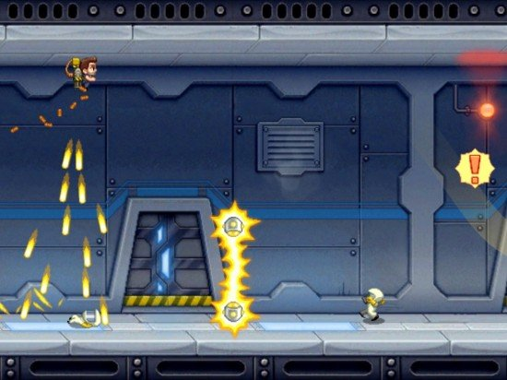

**Artstyle:**

Cartoon + Pixel art (Reference from Jetpack Joyride)

I am proposing 2D because within 2 months it will be a good time to produce many art content using pixel/cartoon art.

I got no time to make what I envision it, but will try to let u guys see it tomorrow.